**Q. Implement a function to find the k-th smallest and k-th largest elements in an array. Use the Red Black Tree approach. Also, Implement a deterministic linear time algorithm to find the median of an array.**

This is implemented using a red-black tree augmented to keep the size of each subtree. This enables one to find the k-th smallest or largest element with very high efficiency.

**Functions:**

1. **Node *createNode(int data)**:
   * **Description**: It creates a new node with the given data and initializes the subtree size to 1, and sets its color to RED.
   * **Parameters**:
     + int data: The value to be stored in the node.
   * **Returns**: A pointer to the newly created node.
2. **void leftRotate(RedBlackTree *tree, Node *x)**:
   * **Description**: It performs a left rotation on the node x. And also adjusts the subtree sizes during the rotation.
   * **Parameters**:
     + RedBlackTree *tree: A pointer to the Red-Black Tree.
     + Node *x: The node on which the left rotation is performed.
3. **void rightRotate(RedBlackTree *tree, Node *y)**:
   * **Description**: Performs a right rotation on the node y. Adjusts the subtree sizes during the rotation.
   * **Parameters**:
     + RedBlackTree *tree: A pointer to the Red-Black Tree.
     + Node *y: The node on which the right rotation is performed.
4. **void fixInsert(RedBlackTree *tree, Node *z)**:
   * **Description**: It avoids the violations in the Red-Black Tree that may occur after inserting a new node. It ensures that the tree maintains its properties.
   * **Parameters**:
     + RedBlackTree *tree: A pointer to the Red-Black Tree.
     + Node *z: The newly inserted node.
5. **void insert(RedBlackTree *tree, int data)**:
   * **Description**: Inserts a new node with the given data into the Red-Black Tree. Adjusts the subtree sizes during insertion and fixes any violations using fixInsert.
   * **Parameters**:
     + RedBlackTree *tree: A pointer to the Red-Black Tree.
     + int data: The value to be inserted.
6. **Node *findKth(Node *root, int k)**:
   * **Description**: Recursively finds the k-th smallest element in the tree using the size of the subtrees.
   * **Parameters**:
     + Node *root: The root of the subtree.
     + int k: The rank of the element to find (1-based).
   * **Returns**: A pointer to the k-th smallest node.
7. **int findKthSmallest(RedBlackTree *tree, int k)**:
   * **Description**: Finds the k-th smallest element in the Red-Black Tree.
   * **Parameters**:
     + RedBlackTree *tree: A pointer to the Red-Black Tree.
     + int k: The rank of the element to find (1-based).
   * **Returns**: The value of the k-th smallest element.
8. **int findKthLargest(RedBlackTree *tree, int k)**:
   * **Description**: Finds the k-th largest element in the Red-Black Tree by converting it into a "k-th smallest" problem.
   * **Parameters**:
     + RedBlackTree *tree: A pointer to the Red-Black Tree.
     + int k: The rank of the largest element to find (1-based).
   * **Returns**: The value of the k-th largest element.

**Example**

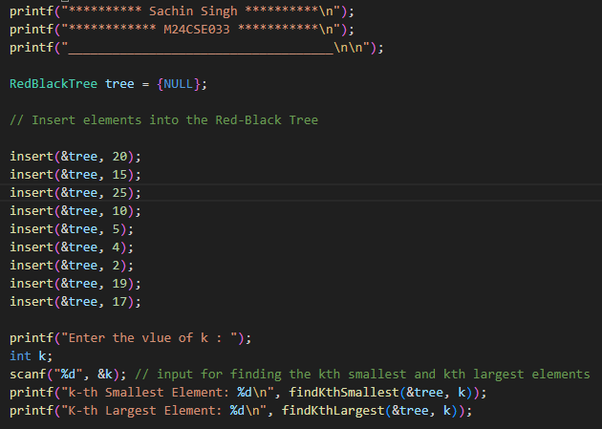

**Output**

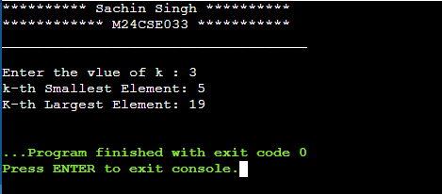

**Deterministic Linear Time Algorithm (Median of Medians)**

This is where the Median of Medians algorithm applies to determine the k-th smallest or median of a given array in linear deterministic time. This algorithm considers breaking the array into groups of 5, finding their medians, and then using those medians to pick an approximate pivot.

Functions:

1. **void swap(int *a, int *b)**:
   * **Description**: Swaps values of two integers.
   * **Parameters**:
     + int *a: Pointer to the first integer.
     + int *b: Pointer to the second integer.
2. **int partition(int arr[], int l, int r, int pivot)**:
   * **Description**: Partitions the array around the given pivot element.
   * **Parameters**:
     + int arr[]: The array to be partitioned.
     + int l: The left boundary of the array.
     + int r: The right boundary of the array.
     + int pivot: The pivot element.
   * **Returns**: The index of the pivot after partitioning.
3. **int findMedian(int arr[], int l, int n)**:
   * **Description**: Finds the median of a small group of size n. This is used to get medians of groups of 5 in the Median of Medians algorithm.
   * **Parameters**:
     + int arr[]: The array to find the median from.
     + int l: The starting index of the group.
     + int n: The size of the group.
   * **Return**: Median of the group.
4. **int kthSmallest(int arr[], int l, int r, int k)**:
   * **Description**: Find the k-th smallest element in the array using the Median of Medians algorithm.
   * **Parameters**:
     + int arr[]: The input array.
     + int l: The leftmost element of the array.
     + int r: The rightmost element of the array.
     + int k: The k-th smallest element (1-based).
   * **Returns**: The element which is k-th small in the given array.
5. **int findMedianOfArray(int arr[], int n)**:
   * **Description**: This function calculates the median of the array using the function kthSmallest. The median is the middle element of a sorted list.
   * **Parameters**:
     + int arr[]: The array.
     + int n: The size of the array.
   * **Returns**: The median of the array.

**Example:**

**Output:**

